Hoofdstuk 5: samenvatting
Lees eerst het boek en gebruik dan deze samenvatting.
Bladzijdenummering niet 100% accuraat!

5) physical basis of neuronal function
- Neuron, soma, dendrite (receive), axon (send), axon terminals.
- Meyelin sheath, no axonal regeneration in higher species.
- Spike initiating zone integrates, often lies in axon hillock → AP: voltage across membrane rapidly rises and falls.
- Sensory/afferent (towards processing), inter-, motor/efferent (→ effectors) neurons. Pre- & postsynaptic.
- Cell clustering, CNS (brain & nervecord), ganglia (collections neuronal somata) distributed along nervecord (→ regions body). Spinal cord (dorsal vertebrate nerve cord). Glial cells (fill space between neurons, though separate fluid filled space; support, [K⁺] & pH regulation); oligodendrocytes & Schwann cells are glial cells.
- Electrically excitable cells (ΔV membrane → respons; e.g. muscle, neurons). Membrane potential, V_{m} (intracellular relative to extracellular, defined 0).
- Resting potential, V_{rest} (usually -20 - -100 mV; large field → moving ions), isopotential.
- Hyperpolarization (V_{m} more negative), depolarization (V_{m} less negative/positive).
- Threshold potential (depolarization) → voltage gated Na⁺ channels → 50% AP. Ion selectivity channels. Leak channels (K⁺ channels; maintain V_{rest}).
- Passive electrical properties (membrane insulator; capacitor: stores energy separated electric charges, measured in coulombs/volt (Farad)).
- ΔV = ΔI∙R (R=1/g; resistance inverse conductance, ↔ ion channels). Input resistance (total resistance encountered current cell).
- Capacitative current (/displacement current; excess ions other side membrane), amount of charge separated depends thickness and dielectric constant.
- Membrane exposed constant current: first mainly I_{c} then mainly I_{r}. V_{t} = V∞ (1-e^{-t/RC}) (V∞ when constant current applied; t=RC: τ). Electrochemical potential. V_{m} dependent maintained concentration gradients and selectivity ion channels.
- Electrochemical equilibrium.
- Equilibrium potential (potential by electrochemical equilibrium for specific ion).
- Nernst: E_{x} = RT/zF ln ([X]_{out}/[X]_{in}) or E_{x} = 0.058 / z log ([X]_{I}/[X]_{II}) (where X is a particular ion).
- Goldman equation: E_{X,Y..} = RT/F log ((P_{x}[X]_{out} + P_{Y}[Y]_{out} + ..) / (P_{x}[X]_{in} + P_{Y}[Y]_{in} + ..)) (where P is relative permeability) for steady state; cells are in dynamic steady state (active processes).
- Na⁺/K⁺ pump (ATP; against leak: 3Na⁺ out 2K⁺ in; electrogenic, though small effect).
- Production AP: (1) asymmetric concentrations, (2) electrochemical gradient, (3) drives ions when specific channels open. Local response. Threshold value → AP regenerative. Overshoot (V_{m} > 0), undershoot/afterhyperpolarization (V_{m} < V_{rest}).
- Absolute & relative refractory period (after AP no AP triggered). Accommodation (slow build-up current increases threshold) determines response neurons input.
- Phasic (fires only once or twice during stimulation) & tonic response (fires continuously), adaptation (less frequent firing over time). Ionic basis response (large increase Na⁺ conductance, slower increase K⁺ conductance).
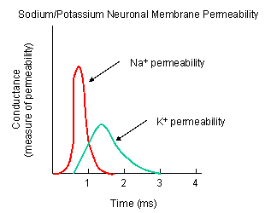
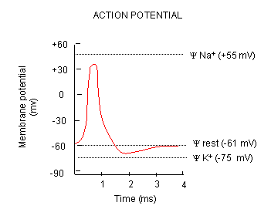
- Voltage gated ion channels, I_{g} (movement of charge → multiple conformational changes).
- Selectivity filter (size, net charge, ease of dehydration [groups pore substitute H₂O]).
- AP stops because channels close after time and current K⁺ channels (and V_{m} reaches E_{na} → slower).
- Outward current K⁺: V_{m} → V_{rest} (or V_{hyper}, which is E_{K}), also I_{k} decreases (because dependent V_{m}).
- K⁺ channels not needed generation AP, but shorten AP (→frequency↑). Refraction period caused inactivation Na⁺ and activation K⁺ (dependent V_{m}).
- Relative refraction caused partially open Na⁺ and open K⁺ channels. Glial cells remove K⁺ wave extracellular spaces, then slowly release it. Structure K⁺ channels: 4 monomeric α subunits form pore, 4 β subunits modulate function.
- Na⁺ channels consist 1 α subunit (functions alone) and associated several smaller β proteins.
- Also Ca²⁺ channels play role some cells (propagate signal and also intracellular messenger; e.g. neurotransmitter release or muscle contraction). Ca²⁺ channels homologues Na⁺ channels, expressed earlier differentiating neurons and messenger → earlier evolution.
- Ca²⁺ channels deactivate by [Ca²⁺]↑. [Ca²⁺]↑ dependent K⁺ channels.

6) Communication along and between neurons
- Passive electrotonic (/decremental) signal transmission (no AP; amplitude diminishes with distance), → AP at spike-initiating zone. Neurotransmitters (release ↔ number & freq APs) → change V_{m} postsynaptic neuron. Postsynaptic potential (psp; ΔV_{m}; graded ↔ stimulus; → spike initiating zone).
- (see other file)

